Game Meat / Viande de gibier
Kangaroo / Kangourou
Salami – 110g

Ingredients: Domestic kangaroo, Pork, Beef, Water, Sugar (maple syrup), Sea salt, Cultured celery powder, Pepper, Garlic, Starter culture, Olive oil, Natural wood smoke.
Ingredients: Kangourou domestique, Porc, Bœuf, Eau, Sucre (sirop d’erable), Sel de mer, Poudre de céleri de culture, Poivre, Ail, Culture starter, Huile d’olive, Fumée de bois naturel.

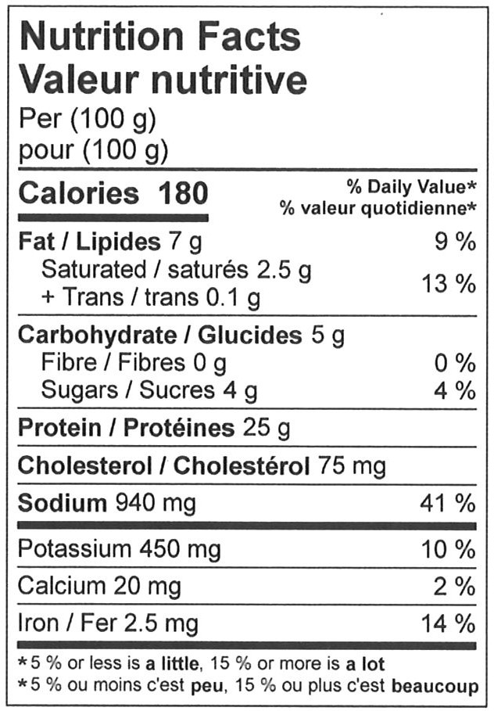

110 g
